String methods:

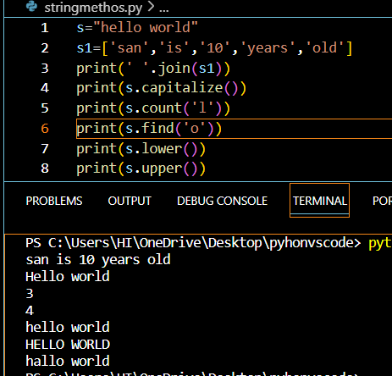

**map()** :

function returns a map object(which is an iterator) of the results after applying the given function to each item of a given iterable (list, tuple etc.)

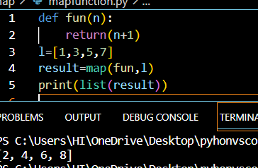

**Lambda Functions** :

are anonymous functions means that the function is without a name. function without names.

When we want to modularize the code to throw it,we use lambda instead of named functions .

Time module:

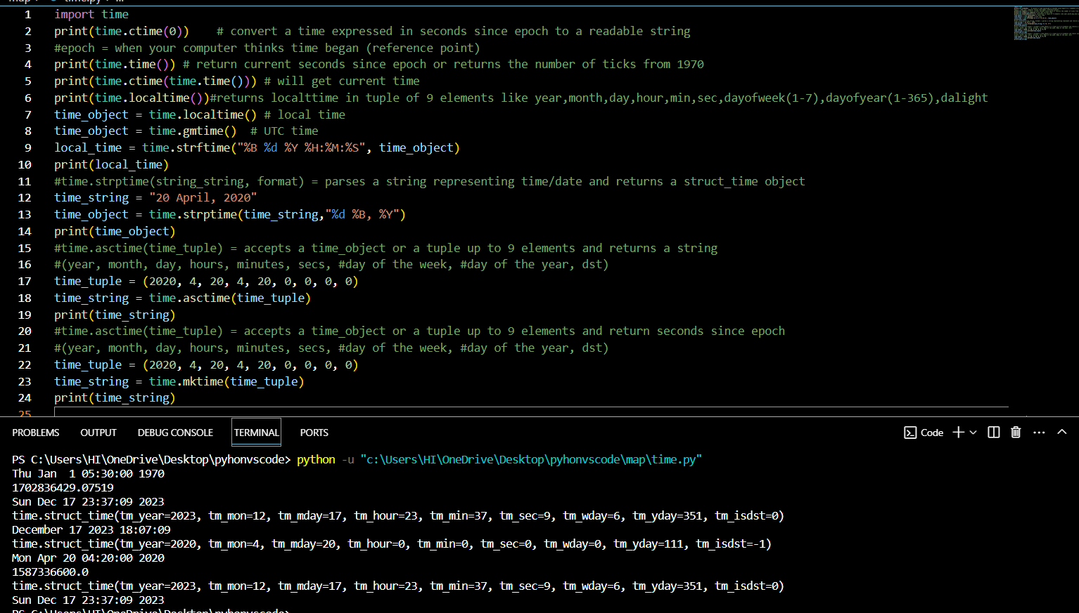

Time.time():returns the current time in seconds starting from the epoch(1970)

Time.localtime():returns the current time in tuple

Time.gmtime:utc time

Time.ctime(secs):converts the time expressed in seconds since epoch to a readable string

That means the given seconds are added to the 1970 date and that total seconds converted to readable string

Time.asctime(tuple):takes a tuple and returns a readable string

Time.mktime(tuple):takes a tuple and returns the time in seconds

time.strftime(format, time_object): formats a time_object to a string

ex: local_time = time.strftime("%B %d %Y %H:%M:%S", time_object)

time.strptime(string, format): parses a string representing time/date and returns a struct_time object

ex: time_string = "20 April, 2020"

time_object = time.strptime(time_string,"%d %B, %Y")

calendar module:

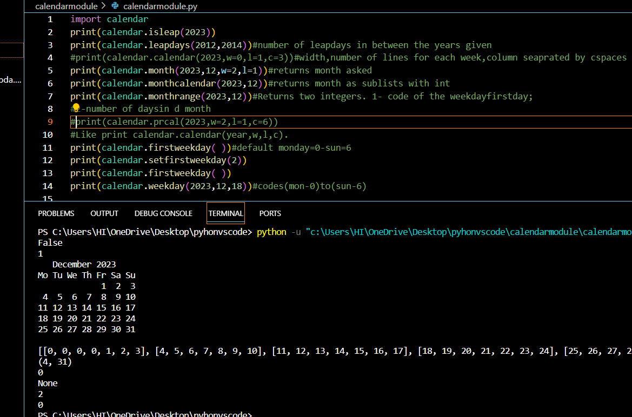

Datetime:

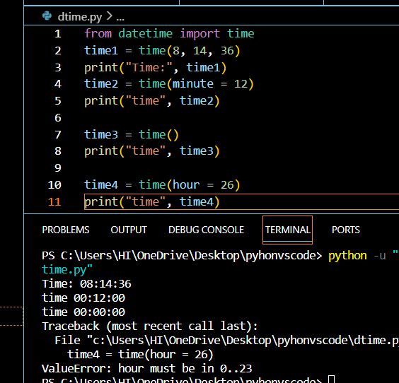

The value is out of range ,so it gives value error

